**Example1: Control Structures**

Scenario 1:

SELECT * FROM CUSTOMERS;

SELECT * FROM LOANS;

SET SERVEROUTPUT ON;

DECLARE

CURSOR CUSTOMER_CURSOR IS

SELECT CUSTOMERID, EXTRACT(YEAR FROM SYSDATE) - EXTRACT(YEAR FROM DOB) AS AGE

FROM CUSTOMERS;

VAR_CUSTOMER_ID CUSTOMERS.CUSTOMERID%TYPE;

VAR_AGE NUMBER;

BEGIN

FOR CUSTOMER_RECORD IN CUSTOMER_CURSOR LOOP

VAR_CUSTOMER_ID := CUSTOMER_RECORD.CUSTOMERID;

VAR_AGE := CUSTOMER_RECORD.AGE;

IF VAR_AGE > 60 THEN

UPDATE LOANS

SET INTERESTRATE = INTERESTRATE - 1

WHERE CUSTOMERID = VAR_CUSTOMER_ID;

ELSE

DBMS_OUTPUT.PUT_LINE('CUSTOMER WITH CUSTOMER ID : ' || VAR_CUSTOMER_ID || ' IS OF AGE : ' || VAR_AGE);

DBMS_OUTPUT.PUT_LINE('NO CHANGE IN LOAN');

END IF;

END LOOP;

COMMIT;

END;

/

SELECT * FROM LOANS;

Output:

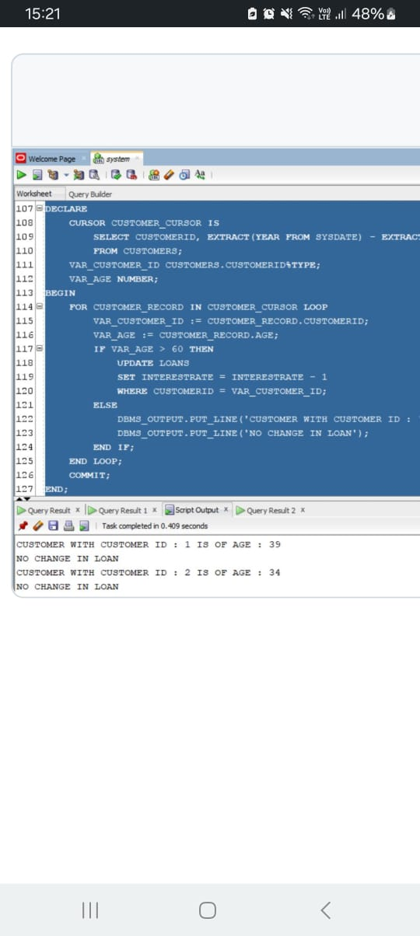

Scenario 2:

DESC CUSTOMERS;

ALTER TABLE CUSTOMERS ADD ISVIP CHAR(10) CONSTRAINT CHK1 CHECK(ISVIP IN ('TRUE','FALSE')) ;

SELECT * FROM CUSTOMERS;

SET SERVEROUTPUT ON;

DECLARE

CURSOR CUSTOMER_CURSOR IS

SELECT CUSTOMERID, BALANCE

FROM CUSTOMERS;

VAR_CUSTOMER_ID CUSTOMERS.CUSTOMERID%TYPE;

VAR_BALANCE CUSTOMERS.BALANCE%TYPE;

BEGIN

FOR CUSTOMER_RECORD IN CUSTOMER_CURSOR LOOP

VAR_CUSTOMER_ID := CUSTOMER_RECORD.CUSTOMERID;

VAR_BALANCE := CUSTOMER_RECORD.BALANCE;

IF VAR_BALANCE > 10000 THEN

DBMS_OUTPUT.PUT_LINE('CUSTOMER ID : ' || VAR_CUSTOMER_ID || ' HAS BALANCE GREATER THAN 10000');

UPDATE CUSTOMERS

SET ISVIP = 'TRUE'

WHERE CUSTOMERID = VAR_CUSTOMER_ID;

ELSE

DBMS_OUTPUT.PUT_LINE('CUSTOMER ID : ' || VAR_CUSTOMER_ID || ' HAS BALANCE LESSER THAN 10000');

UPDATE CUSTOMERS

SET ISVIP = 'FALSE'

WHERE CUSTOMERID = VAR_CUSTOMER_ID;

END IF;

END LOOP;

COMMIT;

END;

/

SELECT * FROM CUSTOMERS;

Output:

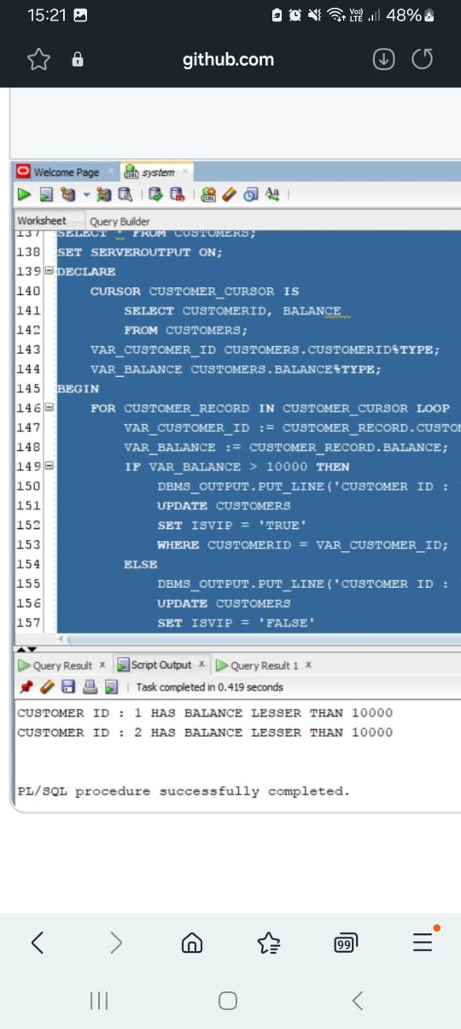

Scenario 3:

SET SERVEROUTPUT ON;

DECLARE

CURSOR CUR_LOANS IS

SELECT L.LOANID, L.CUSTOMERID, C.NAME, L.ENDDATE

FROM LOANS L

JOIN CUSTOMERS C ON L.CUSTOMERID = C.CUSTOMERID

WHERE L.ENDDATE BETWEEN SYSDATE AND SYSDATE + 30;

V_LOAN_ID LOANS.LOANID%TYPE;

V_CUSTOMER_ID LOANS.CUSTOMERID%TYPE;

V_CUSTOMER_NAME CUSTOMERS.NAME%TYPE;

V_END_DATE LOANS.ENDDATE%TYPE;

V_FOUND BOOLEAN := FALSE;

BEGIN

OPEN CUR_LOANS;

LOOP

FETCH CUR_LOANS INTO V_LOAN_ID, V_CUSTOMER_ID, V_CUSTOMER_NAME, V_END_DATE;

EXIT WHEN CUR_LOANS%NOTFOUND;

V_FOUND := TRUE;

DBMS_OUTPUT.PUT_LINE('Reminder: Loan ' || V_LOAN_ID || ' for customer ' || V_CUSTOMER_NAME || ' (ID: ' || V_CUSTOMER_ID || ') is due on ' || TO_CHAR(V_END_DATE, 'YYYY-MM-DD'));

END LOOP;

CLOSE CUR_LOANS;

IF NOT V_FOUND THEN

DBMS_OUTPUT.PUT_LINE('No loans are due within the next 30 days.');

END IF;

END;

/

/*

Output:

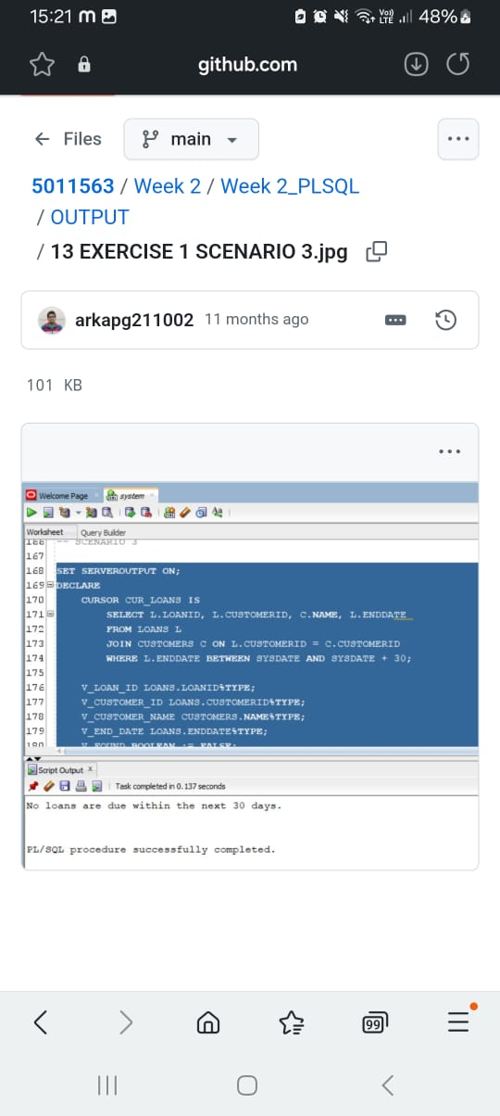

**Example3: Stored Procedures**

Scenario 1:

SELECT * FROM ACCOUNTS;

SET SERVEROUTPUT ON;

CREATE OR REPLACE PROCEDURE PROCESSMONTHLYINTEREST AS

BEGIN

UPDATE ACCOUNTS

SET BALANCE = BALANCE * 1.01,

LASTMODIFIED = SYSDATE

WHERE ACCOUNTTYPE = 'Savings';

COMMIT;

DBMS_OUTPUT.PUT_LINE('Monthly interest processed for all savings accounts.');

EXCEPTION

WHEN OTHERS THEN

ROLLBACK;

DBMS_OUTPUT.PUT_LINE('Error processing monthly interest: ' || SQLERRM);

END PROCESSMONTHLYINTEREST;

/

EXEC PROCESSMONTHLYINTEREST();

SELECT * FROM ACCOUNTS;

Output:

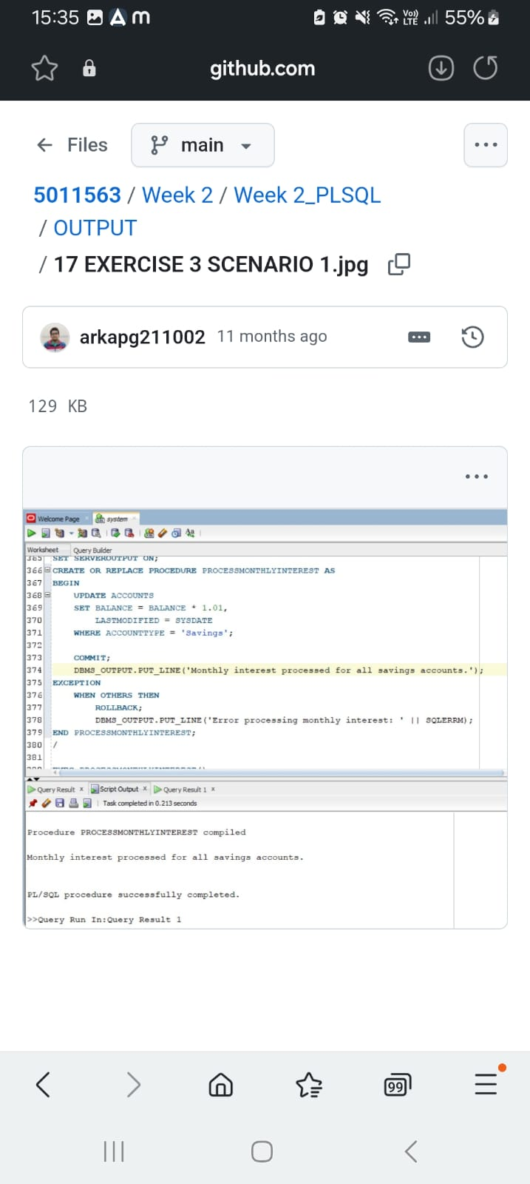

Scenario 2:

SELECT * FROM EMPLOYEES;

SET SERVEROUTPUT ON;

CREATE OR REPLACE PROCEDURE UPDATEEMPLOYEEBONUS(

P_DEPARTMENT IN EMPLOYEES.DEPARTMENT%TYPE,

P_BONUS_PERCENTAGE IN NUMBER

) AS

BEGIN

UPDATE EMPLOYEES

SET SALARY = SALARY * (1 + P_BONUS_PERCENTAGE / 100),

HIREDATE = SYSDATE

WHERE DEPARTMENT = P_DEPARTMENT;

COMMIT;

DBMS_OUTPUT.PUT_LINE('Bonus applied to employees in the ' || P_DEPARTMENT || ' department.');

EXCEPTION

WHEN OTHERS THEN

ROLLBACK;

DBMS_OUTPUT.PUT_LINE('Error updating employee bonuses: ' || SQLERRM);

END UPDATEEMPLOYEEBONUS;

/

EXEC UPDATEEMPLOYEEBONUS('IT',5);

EXEC UPDATEEMPLOYEEBONUS('HR',3);

SELECT * FROM EMPLOYEES;

Output:

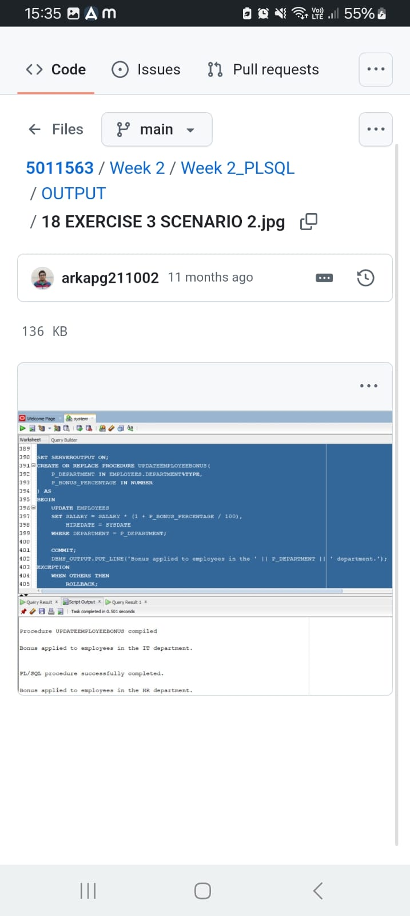

Scenario 3:

SELECT * FROM ACCOUNTS;

SET SERVEROUTPUT ON;

CREATE OR REPLACE PROCEDURE TRANSFERFUNDS(

P_FROM_ACCOUNT_ID IN ACCOUNTS.ACCOUNTID%TYPE,

P_TO_ACCOUNT_ID IN ACCOUNTS.ACCOUNTID%TYPE,

P_AMOUNT IN NUMBER

) AS

V_FROM_BALANCE ACCOUNTS.BALANCE%TYPE;

BEGIN

SELECT BALANCE INTO V_FROM_BALANCE

FROM ACCOUNTS

WHERE ACCOUNTID = P_FROM_ACCOUNT_ID

FOR UPDATE;

-- Check for sufficient funds

IF V_FROM_BALANCE < P_AMOUNT THEN

RAISE_APPLICATION_ERROR(-20001, 'Insufficient funds in the source account.');

END IF;

-- Perform the transfer

UPDATE ACCOUNTS

SET BALANCE = BALANCE - P_AMOUNT,

LASTMODIFIED = SYSDATE

WHERE ACCOUNTID = P_FROM_ACCOUNT_ID;

UPDATE ACCOUNTS

SET BALANCE = BALANCE + P_AMOUNT,

LASTMODIFIED = SYSDATE

WHERE ACCOUNTID = P_TO_ACCOUNT_ID;

COMMIT;

DBMS_OUTPUT.PUT_LINE('Transfer of ' || P_AMOUNT || ' from account ' || P_FROM_ACCOUNT_ID || ' to account ' || P_TO_ACCOUNT_ID || ' completed successfully.');

EXCEPTION

WHEN OTHERS THEN

ROLLBACK;

DBMS_OUTPUT.PUT_LINE('Transfer failed: ' || SQLERRM);

END TRANSFERFUNDS;

/

EXEC TRANSFERFUNDS(1,2,100);

SELECT * FROM ACCOUNTS;

/*

Output:

